Module – 5 Python Fundamentals

- Introduction to Python
- Introduction to Python and its Features (simple, high-level, interpreted language).
- Python is an interpreted, object-oriented, high-level programming language with dynamic semantics.
- Its high-level built in data structures, combined with dynamic typing and dynamic binding, make it very attractive for Rapid Application Development.
- Features :- Easy to learn and Read
Free and Open source
Uses white-space to delimit blocks
Variables do not need declaration

Lab :- Write a Python program that prints "Hello, World!" & write a program to display your name.
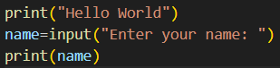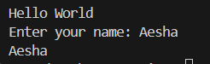

- Programming Style
- Understanding Python’s PEP 8 guidelines. Indentation, comments, and naming conventions in Python.
- Indentation (spaces) → 4 spaces per level.
- Comments → Use # for single-line, """...""" for docstrings.
- Naming → Variables & functions → snake_case (all lowercase with underscores)
Constants → UPPER_CASE
Classes → PascalCase (CapWords).

Lab :- Write a Python program that demonstrates the correct use of indentation, comments, and variables following PEP 8 guidelines.
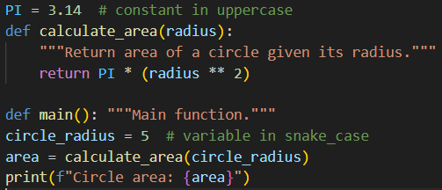

- Core Python Concepts
- Understanding data types: integers, floats, strings, lists, tuples, dictionaries, sets.
- Integers (int): Represent whole numbers, positive or negative, without a decimal point.
Eg :- age = 30
negative_number = -15
- Floats (float): Represent numbers with a decimal point, used for fractional or real numbers.
Eg :- pi = 3.14159
- Strings (str): Represent sequences of characters, enclosed in single, double, or triple quotes.
Eg :- name = "Aesha"
message = 'Hello, world!'
- Lists (list): Ordered, mutable collections of items enclosed in square brackets []. Lists can contain elements of different data types.
Eg :- my_list = [1, "apple", 3.14, True]
- Tuples (tuple): Ordered, immutable collections of items enclosed in parentheses ().
Eg:- my_tuple = (10, "banana", False)
- Sets (set): Unordered collections of unique items enclosed in curly braces {}. Sets do not allow duplicate elements.
Eg :-my_set = {1, 2, 3, 2, 4} # Result will be {1, 2, 3, 4}

- Python variables and memory allocation.
Variable is a name that refers to a value stored in memory.

- Python operators: arithmetic, comparison, logical, bitwise.
Python operators are special symbols that perform operations on values and variables.
1. Arithmetic Operators :- These perform basic mathematical calculations.
Operator | Name | Example
+ | Addition | x + y
- | Subtraction | x - y
* | Multiplication | x * y
/ | Division | x / y (returns float)
% | Modulus | x % y (remainder)
** | Exponentiation | x ** y
// | Floor Division | x // y (returns integer part)

2. Comparison Operators :- These compare two values and return a boolean result (True or False).
Operator | Name | Example
== | Equal to | x == y
!= | Not equal to | x != y
> | Greater than | x > y
< | Less than | x < y
>= | Greater than or equal to | x >= y
<= | Less than or equal to | x <= y

3. Logical Operators :- These operators combine conditional statements.
Operator | Description | Example
and | Returns True if both conditions are true | (5 > 2) and (10 > 5) evaluates to True
or | Returns True if at least one condition is true | (5 > 2) or (10 < 5) evaluates to True
not | Reverses the logical state of its operand | not (5 > 2) evaluates to False

- Bitwise Operators :- These operators perform operations on the binary representation of integers.

Lab :- Write a Python program to demonstrate the creation of variables and different data types.
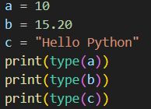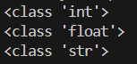

- How to take user input using the input() function.

- Conditional Statements
- Introduction to conditional statements: if, else, elif.
- The if Statement :- The if statement is the most basic conditional statement. It evaluates a condition, and if the condition is true, a specific block of code is executed.
Syntax :- if condition:
# Code to execute if the condition is true

- The else Statement :- The else statement is used in conjunction with an if statement to provide an alternative block of code to execute if the if condition is false.
Syntax :- if condition:
# Code to execute if the condition is true
else:
# Code to execute if the condition is false

- The elif Statement (Else If) :- The elif statement, short for "else if," allows for checking multiple conditions sequentially.
Syntax :- if condition1:
# Code to execute if condition1 is true
elif condition2:
# Code to execute if condition1 is false and condition2 is true
elif condition3:
# Code to execute if condition1 and condition2 are false, and condition3 is true
else:
# Code to execute if all preceding conditions are false

Lab :- Write a Python program to find greater and less than a number using if_else.
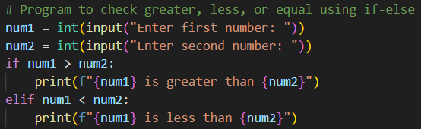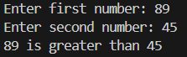

- Write a Python program to check if a number is prime using if_else.
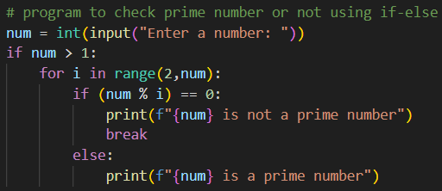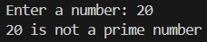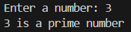

- Write a Python program to calculate grades based on percentage using if-else ladder.
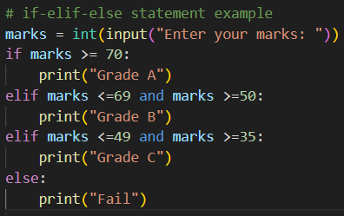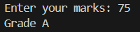

- Write a Python program to check if a person is eligible to donate blood using a nested if.
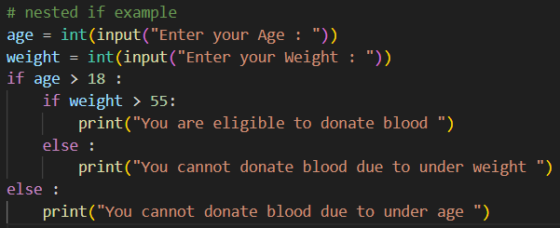
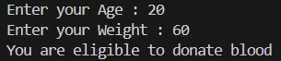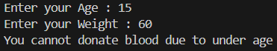
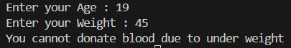

- Looping (For, While)
- Introduction to for and while loops.
For Loop :- The for loop is used for iterating over a sequence (like a list, tuple, string, or range). t is typically used when the number of iterations is known.
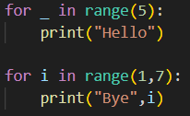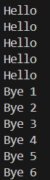
While Loop :- The while loop repeatedly executes a block of code as long as a specified condition remains True. It is used when the number of iterations is not known in advance.
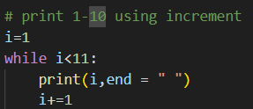

- Using loops with collections (lists, tuples, etc.).
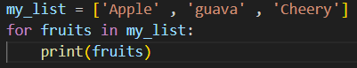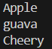

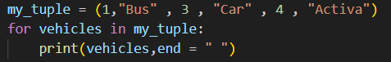

Lab :- Print this pattern using nested for loop: *
**
***
****
*****
